T A B L E O F C O N T E N T S

1. SUBMISSION LETTER

2. CURRICULUM VITAE PERSONAL

3. E C V UWINDSOR

4. TEACHING DOSSIER
- PEDAGOGY, RESEARCH OBJECTIVES
- TEACHING METHODOLOGY
- CLOSING
- ALL COURSE SYLLABI
- 1070: Studio Practice and Ideas | Drawing
- 1060: Studio Practice and Ideas | Image
- 1100: Drawing for Non-Majors
- 2030: Introductory Drawing 1200: Architectural Design II
- 2130: Introductory Painting
- 3030: Drawing
- 3130: Painting
Custom Practice (no outline)
- 3650: Independent Studio
- 4800: Studio Practice I
- 4810: Studio Practice II
- Remote Delivery
- 4910: Online Critical Issues

5. INITIATIVE FILES

6. S E T SOLICITED FEEDBACK

7. LETTERS OF GRATITUDE

8. DOSSIER 2017/2012



School of Creative Arts | Visual Arts
37 University Ave. E, Windsor
Ontario, Canada N9A 1E4
T 519.253.3000 ext. 2829
soca@uwindsor.ca
www.uwindsor.ca/soca

Committee for Renewal, Tenure and Promotion August 11th, 2022
401 Sunset Avenue
Windsor, Ontario
N9B 1K6

RE: Promotion Lecturer III

I appreciate the opportunity to reflect on the last 5 years since my Dossier submission in 2017. As I wrap up my 19th year at the School of Creative Arts this fall, I am feeling a little pride. However difficult the last 2 years have been {I think we can all agree ~ the pandemic rocked us to the core!}, in retrospect I hung in and even rallied a few times. I must admit I finally feel the fog of the pandemic is lifting, and I am beginning to think /dream again, ever so carefully.

I set out in my preparation of this review and application to make reference to the pandemic as little as possible. As the pandemic chaos like; the curbside supply scramble, health protocol confusion, fear of breathing, zoom fatigue, bedroom art and $450.00 phone bill after using my cell as a hot spot to deliver a lecture in my internet-less studio, is slipping into the rear view mirror I am now able to recognize that I am left with some new knowledge, and some useful formidable training.

I recognize that were it not for the pandemic, I would NEVER HAVE; taken an online Drawing Marathon at the spectacular New York Studio School led by the renown Dean Graham Nickson, learned my way around platforms like, Enscape, Padlet, Kuula, Procreate and Sketchup, or managed the complex online studio delivery method with 5 courses, 3 cameras, production lighting and prerecorded demos.

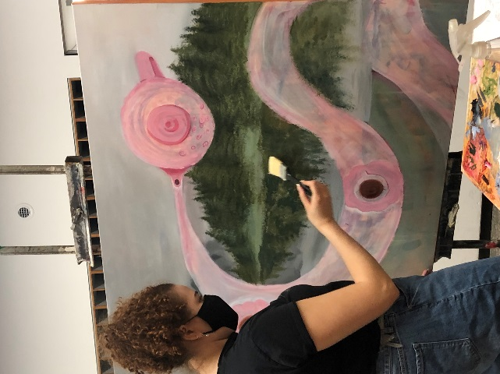
I never thought that simply doing my job F2F in studio could feel radical, but I persevered and felt proud of trying to put SoCA on the map by being part of the 2% back in studio in the Fall of 2021 and the 4% in the Winter Semester 2022. It was worth every odd moment. The students in studio were very understanding and fabulous.

The benefits of the push back to studio were realized just before reading break this winter semester. I found one of our truly exceptional BFA students, Emma McGee wandering through the studios. I screamed her name, it was loud, we were equally happy to see each other. We discussed the frustration surrounding the fact that the final project in painting 200 level, was just about to begin when covid hit in March 2020. I invited her into our current 2022 painting group so that she could pick up where she left off in the course. We immediately prepared a large stretcher together, and she attended each class until the end of the semester and was able to complete the experience and her final painting with a new group of painters.

This is Emma.

One little pandemic triumph!

19 years of teaching was moved swiftly was a little heart wrenching and at the end of the day was truly fascinating. I have loved the autonomy of my positions and picking and choosing projects and initiatives that I truly felt served the undergraduate student body. The truth is I actually really love these students, I imagine if you didn’t you wouldn’t last very long and most certainly they would feel that.

I define my contribution as a boots on the ground, ‘how can I get you what you need’ ~ liaison.

One student at a time.

I am proud of my will in an attempt to make things better than I found them. That ongoing agenda certainly hasn’t come to a close and hopefully when I leave, that is something I aspire to say to myself as I lock my office door one last time. Whether it was spearheading a fundraiser which involved designing and renovating the LeBel gallery, which had the direct effect of providing a more professional space for the students for 12 years, or taking the lead in the drawing and painting department as a sessional, and fulfilling all the requests and obligations to designing our new space downtown.

I have learned that listening to students and truly ‘noticing them’ does not come easily. Many of our students reach out for assistance, and request the type of care that has little to do with being their instructor and everything to do with being human. I actually feel quite privileged that I was the one they came to occasionally I was able to help.

In this Dossier I would like to focus on the students that have dotted my history at the school, students I will not soon forget.

Three students come to mind, Isabella Cheng (2013), Kathy Gulko (2010) and Erin Donnelly (2017).

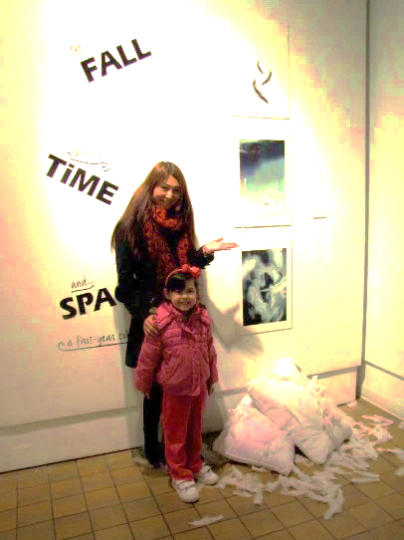
Isabella Cheng (2013) Isabella was separated from her parents when she was 4. Isabella’s parents and brother traveled to Manhattan from China to get a visa, search for work and find a home. Isabella stayed with her Grandparents back in China, with a promise that they would fly back to retrieve her once settled. On September 11, 2001 after the terrorists attack in New York, everything changed . Isabella’s parents were denied legal status – a passport or visa. Isabella’s grandparents flew to Toronto with her in an attempt to travel through to New York and reunite Isabella with her family. They were denied entry. Isabella’s relatives in Toronto took her in and her Grandparents returned to China. She proceeded to live in basements and porches being passed from one home to another. At 7 years old, her relatives traveled to Windsor and attempted to smuggle her across the Windsor/Detroit border in a suitcase. She was seized by social services and put into an orphanage in Detroit and eventually returned to Canada. She was in foster care and was adopted by her foster family. When we met at 18 years old she had never seen her parents, or a sister since they left her in China at age 4. She had a brother she had never met. She had been without her family for 14 years , and only a 9 hour car ride away to New York State.

When Isabella told me this story I was speechless. I mobilized all Legal contacts that I had, contacted the lawyer for the Children’s Aid Society, my partner (commercial litigator) constructed a letter of urgency to be hand delivered to the Canadian Consulate by Isabella in Toronto. We prepared letters of support for a passport to the Immigration Office and every form that we could research to the Canadian Consulate. While she was unable to travel to New York while she was at SoCA, the wheels were in motion. A year after Isabella graduated from our program, she sent me a picture of her first meeting with her parents in New York. I will never forget her smile, while she sat next to her Brother and the Sister she had never known and her dear Mother and Father.
This is a moment I will never forget. 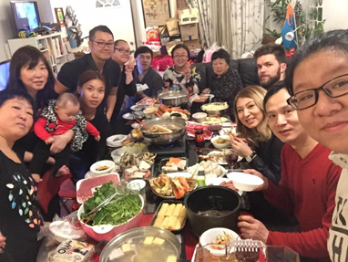 Isabella

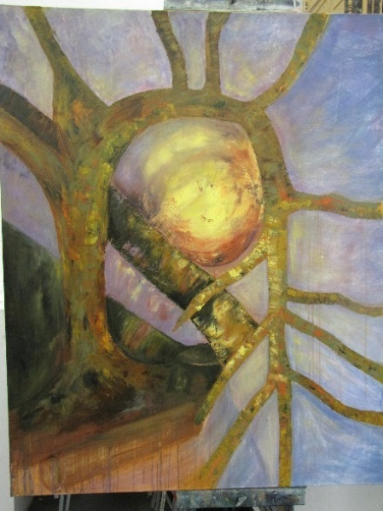
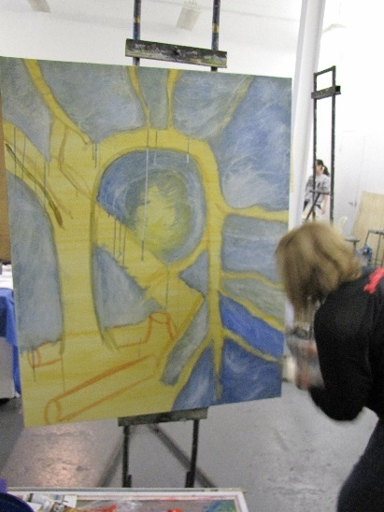
Kathy Gulko (2010) – Kathy Entered our program as a mature student around 2010. When I first met her, she was in mourning.
Kathy’s Husband perished in a boating accident on their family boat on Lake Erie. 6 months later she sat in a chair glassy-eyed in my painting class. She was gutted. I helped her created a painting in honor of her spouse of almost 22 years. I went to the area where her husband perished. We found a source. This is Kathy, she found solace in her work.

I will never forget this painting
nor will I forget Kathy.

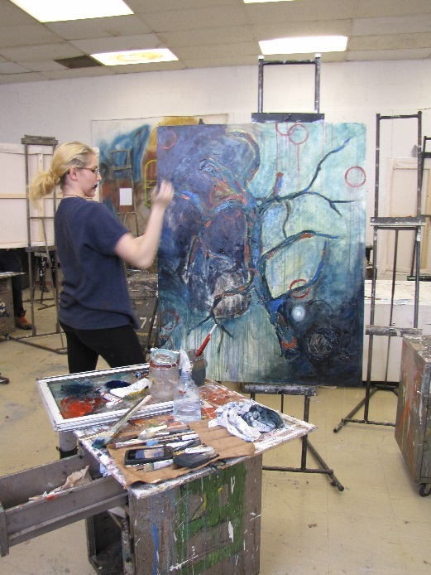
Erin Donnelly (2017) – Erin was giving up, rethinking her choices, she was in 3rd year, and she was flailing. I found her slumped over at an easel in the Lebel Building. I sat with her for hours, and she told me her story, her family, struggles. She had no direction and had no idea what she was doing, she was completely lost. I grabbed and easel threw it in my truck and took her out on site. I told her I didn’t want the easel back until she had ‘this’. She went to work. I didn’t see her for 3-4 weeks. Then she knocked on my office door, eyes sparkling and full of plans, enthusiasm and pride. That was a tipping point, we started to devise a plan for graduate school. She attended the University of Ottawa, MFA Program. She completed her studies in the spring 2022 and I have no doubt she will find placement and land.

I was always very honest with Erin as a result she has no false hope and understands the road might be challenging. She has to be able to move, pick up and go, no guarantees – take everything that is offered, look for your next opportunity, make a difference – have GRIT.
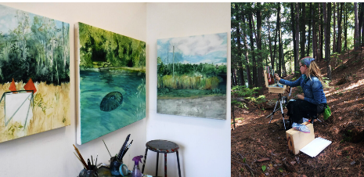
-----Original Message-----
From: Erin Donnelly <donnell1@uwindsor.ca>
Sent: Tuesday, January 15, 2019 11:41 AM
To: Lisa Baggio <studio@lisabaggio.com>
Subject:

Thank you so much Lisa,

I wouldn’t be where I am at today as an artist and painter without you. You saw something in me I don’t know if I saw myself, and you called me out when I needed it most and was losing my own voice as a painter. My current artistic vision is all because of those first year plein air you sent me out in the world to complete in two weeks’ time. I admire you not just as a painter and professor but as a friend. How you conduct yourself in and outside your classroom is what inspired me to want to teach myself, and be able to have the same influence on new minds and talents like you did for me. You’ve pushed me to somewhere I never thought possible, and pulled out my already existing talents from somewhere I didn’t know existed.

I’ll be forever grateful for the roles you have played in my development as an artist Erin

That is my job, this is our culture, one story at a time, the returns are immeasurable.

Lisa Catherina Baggio | c u r r i c u l u m v i t a e

lbaggio@uwindsor.ca

Education

Yale University, Yale School of Art
New Haven, Connecticut, U.S.A
1992 Masters Fine Arts (Painting – Printmaking)

University of Victoria
Victoria, British Columbia, CANADA
1989 Bachelor of Fine Arts, Honours Program

Independent Study
Paris, France
1985/86 Research of Flemish and French Artists, 16th century
Painting

Parsons School of Design
New York, NY, U.S.A
1983 Foundation Program

Academic Positions _____________________________________________

LECTURER STUDIO ARTS| DRAWING AND PAINTING
University of Windsor, School of Visual Art - Windsor, Ontario
1995/96, 2004 - 2012 – Sessional
2012 - present – Lecturer
Instructor of studio courses in the disciplines of drawing, painting, and image.

VISITING LECTURER | PAINTING
Thames School of the Arts
2013 – 40 hour compressed Studio Course

VISITING LECTURER | PAINTING
Haliburton School of the Arts
2011 – 40 hour compressed Studio Course

VISITING LECTURER | DRAWING
Thames School of the Arts
2010 – 40 hour compressed Studio Course

YOUTH EDUCATION WORKSHOP - DIRECTOR
University of Windsor – OPEN STUDIO WORKSHOPS
(Cooperative Initiative for BFA Students | Education)
2003-2006
The impetus for this project was the dwindling arts presence in most secondary school curriculum. The workshop was open to gifted student in senior primary and secondary school students for an intensive three-day studio workshop.

TEACHING FELLOWSHIP
Yale University, School of Art (Architecture)
1990 – 1992- Teaching assistant of Professor Richard Lytle – Drawing / Painting.

Projects and Initiatives_ ______________________________________________

ELEVATE YOUR SPACE – DIRECTOR, DESIGNER, ARTIST
2019-2020
Elevate your Space is an ongoing public indoor mural project that serves to educate, incorporate and facilitate public creativity and connection to space. Over 50 non-artists participated in the design and execution of a 500 square foot mural. Participants were asked to compile images of a transformative space that they have encountered in their travels or daily lives. The execution involved senior students within SoCA and the education department at the University of Windsor. Most importantly the general public became artists and critics and it was an overwhelming success. (PLEASE SEE THE TIMELAPSE VIDEO IN “ lisabaggio.com -Projects”)

EARTH HOUR SoCA IN THE DARK
MAR. 2018
Community Visual Arts Event – Liaison Casino Windsor Community Engagement. (-10c :o)

OPEN STREETS – OPEN DOORS -PROJECT LIAISON
2018
Open Doors, Windsor is an initiative to open buildings that would not normally be accessible to the public. All access to buildings during this event is free of charge. Foster community connections and invite the community into our new space. Enjoy the differences in architecture, places of worship, and workplaces.

PRINTS CHARMING- DEACCESSION | TRANSFER | FUNDRAISER
4000 PRINTS – DONATION TO WINDSOR PRINTMAKERS FORUM
2016-2017

MONSTER DRAW- RECRUITMENT INITIATIVE-SECONDARY SCHOOLS
2016

UNIVERSITY OF WINDSOR, SoCA – LIAISON projects for student placements
2014-2015
Garden Retreat Sculpture Project 2014- Metropolitan Hospital - Jessica Westlake
Pediatrics Plexiglass Installation 2014/15– Metropolitan Hospital – Kristina Greco
Then and Now 2014/15 – Reko Tool Mural – Graeme Skelton

BASQUAIT – COLLABORATION WITH CMF

Jean-Michel Basquiat: Now's the Time | AGO Art Gallery of Ontario
2015
55 Students – 2 days- Explore the exhibition and the Toronto Artists culture.

MOVIE NIGHT – STUDENT GATHERINGS
OFF CAMPUS – Bonding and collaboration initiative.
2013- FALL

TSUNAMI – THE BUSINESS OF ART SERIES
Eva Milinkovic and Chris Gene discuss the business side of making, logistic of running a successful glass blowing shop. Some employment opportunities have been realized as a result.
2011-2015

DAVID FINCH- MARVEL COMICS - BEYOND THE PEN
Demos and question periods -working in the animation field.
WORKSHOPS AND LECTURES (200 LEVEL DRAWING)
2012-2013

TSUNAMI GLASSWORKS, 2440 CENTRAL AVE, WINDSOR
2008-2013

LEBEL GALLERY RESTORATION PROJECT
PROJECT DIRECTOR – FUNDRAISER - DESIGNER -PROJECT MANAGER
2004-2007
This project involved reaching out to community leaders in a fundraising effort to raise funds to disassemble the current gallery space. I worked in collaboration with Architecturra to design and renovate the space. The results were a complete transformation of the gallery into a new professional exhibition venue. The University of Windsor matched fundraising efforts.
The kickoff for the unveiling of the new gallery was celebrated with an alumni exhibition – which I curated in collaboration with the Elaine l Jacob gallery director and Curator Sandra Dupret Smith.

OPEN STUDIO WORKSHOPS SERIES- recruitment primary and secondary – public and catholic school boards
2004-2005

VISITATION PARISH - COLOR AND RESTORATION CONSULTANT - COMMISIONED ARTIST – DIRECTOR- Belle River, Ontario
2006

a) CONSULTANT – INTERIOR DESIGN AND PRESERVATION
Consultant regarding preservation of Architectural emblems and transference said design elements into the new structure. (Queens University Restoration Department – Masters Program)

b) COMMISIONED ARTIST – SITE SPECIFIC WORK
A 6’ diameter painting was created and installed as the only painted image to adorn the altar of the newly constructed church.

c) RESTORATION AND REPAIR – (Co-operative Initiative Students BFA Program)
Statues were repaired and restored. New color schemes were applied to all statues. Collaboration with Restoration Department at Queens University

d)THE CHILD’S PLACE – CONSULTANT / PROJECT MANAGER
1997
Grant proposal and fund acquisition for a site-specific interactive sculpture for the interior lobby of the rehabilitation center. Joe DeAngelis Artist.

PROJECT DIRECTOR/ARTIST
1984 – 1985
Sacred Heart Church - LaSalle, Ontario
Artist and designer of 707sq.ft mural on a concave surface interior dome. Responsible for full execution of project, drawing design and painting. Painting subject, ‘Last Judgment’.

Professional Development__________________________________________

DEVELOPMENT OFFICER
Art Gallery of Windsor - Windsor, Ontario
1994-1996
Maintenance of corporate and private rental accounts and the sale of contemporary works of art. Working in association with the volunteer committee on several fundraising events.

COMMERCIAL DRAFTING
Southridge Co. Ltd. - Windsor, Ontario
1991 - 1993. This position entailed drafting and detailing of residential blueprints and interiors. The position also involved commercial plot plans. All drafting done on AUTOCAD Release 11.

DEVELOPMENT OFFICER/ GALLERY ASSISTANT
Art Bank Gallery - Victoria, British Columbia
1989 This position entailed selling original works of art and limited-edition prints. Advertising and public relations.

HERITAGE INTERPRETER ARTIST
(Corporation of the City of Windsor)
Mackenzie Hall Cultural Center, Windsor, Ontario
1988 This position was based on a grant funded by the Canada Arts Council. The position involved designing three permanent display cases by interpreting the heritage of the area and the history of the building. The position also involved doing site-specific pieces for the building.

TEACHING POSITION
(Corporation of the City of Windsor)
1988 Summer Session teaching position in the field of intermediate painting and materials.

DIRECTOR/ ARTIST
Multi-Cultural Club of Windsor - Windsor, Ontario
1988 Project director, execution, and design of two site-specific pieces.

Curatorial Projects_________________________________________________________________

2022 Paracosm – Joe Ishaq, Solo Exhibition
2020 Til We Meet Again - LaSalle Virtual Exhibition (Graduating Exhibition)
2015 BFA Graduating Exhibition
2014 BFA Graduating Exhibition
2013 Geology 300 level student exhib. LeBel Gallery
2013 Kingdom 300 level students exhib. LeBel Gallery
2012 P=f P = F/A x T Drawing 300 level- LeBel Gallery
2011 Faculty of Law -Legal Aid Initiative
2010 Eye for Art Biennial – CHATHAM KENT ART GALLERY – Curator, Juror
2010 Tacks and Traces - THE WELLINGTON -OFFSITE GRADUATING EXHIBITION
2009 LEBEL GALLERY FACULTY EXHIBITION
2008 NOBEL PEACE INITIATIVE – Susan Gold-Smith, Artist
2008 FACULTY EXHIBITION – UNIVERSITY OF WINDSOR
2007 UNIVERSITY OF WINDSOR – FLOURISH
Alumni Exhibition running concurrent with the opening of the newly renovated LeBel Gallery.
2006 LEBEL GALLERY FACULTY EXHIBITION
2005 LEBEL GALLERY FACULTY EXHIBITION
2004 LEBEL GALLERY FACULTY EXHIBITION
2003 LEBEL GALLERY PAINTING EXHIBITION

Private Exhibitions/Group Exhibitions_____________________________________________

2011 Oh Canada!...beyond trees and water- Elaine L. Jacob Gallery
Wayne State University, Detroit MI.
2006 Site specific installation Visitation, Belle River, Ontario
2005 Images of Time and Place: Contemporary Views of Landscape
Elaine L. Jacob Gallery- Michigan MAR 2005
2005 Group Show- Jan/04
2004 Lebel Gallery – Windsor, Ont.
2002 Group Show-Mar/02
Yale University – Yale University, New Haven, CT
2001 Group Show- Feb/01
Art Gallery of Mississauga – Mississauga, Ontario
1995 Faculty Exhibition - Jan/95
University of Windsor, School of Art - Windsor, Ontario
1992 Burlington Fine Arts Gallery – Jan/92
Burlington, Ont. Group Show
1991 Thesis Show
Yale School of Art Gallery - Yale University, New Haven, CT
1990 Student Collection of New Work -
Art and Architecture Gallery - Yale University, New Haven, CT
1989 The Vancouver Island Invitational
The Art Gallery of Greater Victoria, June - Aug 89
Three-person show.

Publications_______________________________________________________________

Knight Foundation
“OH, Canada”
Nov. 18, 2011- V. Miller

Online Medium- University of Toronto, Gia Perreira,
Review of Art Gallery of Mississauga- Group Showing
Building Josie I
V28-Issue-16- 2002

Tim Lougheed, “A Dome to Equal Baroque Classics”, The Windsor Star
Egidio Novelietto - “Una Giovane Atista Che ci fa Onore”
Publ. Jul 85 p.6 Casola Publ.

AWARDS, SCHOLARSHIPS, GRANTS_________________________________________________

AWARD- University of Windsor
Meritorious Service Award – 2007 – presented by Ross Paul President of the University of Windsor

GRANT - Chandisherry Foundation – LeBel Restoration Project -$25,000.00

GRANT - BlackBurn Foundation – LeBel Restoration Project -$6,000.00

GRANT- Childs place – Ontario Arts Council Grant - $10,000.00

AWARD - Richard Wellington Award - Excellence in Studio Drafting
Yale University School of Art, New Haven, CT

GRANT - Scholarship - Tuition Award -$25,000.00
Yale University School of Art, New Haven, CT

GRANT - Scholarship – Senior Award Full Tuition -$8,000.00
British Columbia Cultural Fund Distributed by British Columbia Arts Board
Scholarship based on merit and grades

GRANT - Scholarship - Tuition Award- $6,800.00
Parson School of Design, New York, NY

Community Education/ Juror / Panels /Advocacy

LIGHTS WINTER FESTIVAL –(November December 2022) Community Project
Partnership Patty Funaro and Scott Bisson – Permanent Site-Specific Community Created work
April 2022

LASALLE SMALL COAST PROJECT – Panel - Representative Site-Specific Outdoor Installation
$24Mil. Project Phase 1 & 2
Feb. 2021

SICK KIDS Foundation Fundraiser
Toronto, Ontario
2019, 2020, 2021, 2022
(tally- 4,200.00 ya!)

W.E.A- Juror - Performing Arts Emerging Artist Grant and the Visual Arts Emerging Artist
Grant. (2016 & 2018)

CANADIAN MENTAL HEALTH ASSOCIATION – Education Volunteer
Windsor, Ontario
2010
Education volunteer

YOGA FOR A CURE- Breast Cancer Fundraising Initiative
One-day event, yoga, and meditation for a cure.
August 25th, 2008 – Windsor, Ontario
http://pajamaangels.org/index_files/Yoga4hope.htm

WINDSOR REGIONAL CHILDREN’S CENTRE – Healing Arts Program
Art therapy Initiative
Windsor, Ontario 2007-2008
Initative to establish liaison between the Healing Arts Program and co-operative possibilities for potential Art Therapy track students. Preliminary stages.
Lindy Leduc-Wilson

BANA Bulimia Anorexia Nervosa Association
Windsor, Ontario 2000 - 2006
Prevention Education Programs- Visual Arts Events Coordinator,
Volunteer.

United Way of Canada
Windsor, Ontario 2004
Visual Art Event Volunteer Program.

Board of Directors – The Child’s Place
Windsor, Ontario 1995-1997
Rehabilitation institution for abused children under age six.

Professional Associations
CARFAC
COLLEGE ART ASSOCIATION
AGW
AGO

UNDERGRADUATE TEACHING (1995-2022)

Course Number Semester Year Course Title Full Year Course

VS-AR-2130-1-R Winter 2022 Introductory Painting No
VS-AR-1070-1-R Winter 2022 Studio Practice &Ideas/Drawing No
VS-AR-1070-2-R Fall 2021 Studio Practice &Ideas/Drawing No
VS-AR-1070-1-R Fall 2021 Studio Practice &Ideas/Drawing No
VS-AR-1070-1-R Winter 2021 Studio Practice &Ideas/Drawing No
VS-AR-3650-4-R Winter 2021 Independent Studio No
VS-AR-1070-3-R Winter 2021 Studio Practice &Ideas/Drawing No
VS-AR-4910-1-R Winter 2021 Critical Issues No
VS-AR-2130-1-R Winter 2021 Introductory Painting No
VS-AR-2030-1-S2 Winter 2020 Introductory Drawing No
VS-AR-2130-1-R Winter 2020 Introductory Painting No
VS-AR-1060-2-R Fall 2019 Studio Practice & Ideas /Image No
VS-AR-1070-30-R Fall 2019 Studio Practice &Ideas/Drawing No
VS-AR-1070-1-R Fall 2019 Studio Practice &Ideas/Drawing No
VS-AR-3650-2-R Fall 2019 Independent Studio No
VS-AR-1070-1-R Winter 2019 Studio Practice &Ideas/Drawing No
VS-AR-2030-1-R Winter 2019 Introductory Drawing No
VA-BE-1200-1-S2 Winter 2019 Architectural Design II No
01-27-107-30 Fall 2018 Studio Practice and Ideas / Drawing No
01-27-365-01 Fall 2018 Independent Studio No
01-27-107-01 Fall 2018 Studio Practice and Ideas / Drawing No
01-27-203-01 Fall 2018 Introductory Drawing No
01-27-303-01 Winter 2018 Drawing No
01-27-107-01 Winter 2018 Studio Practice and Ideas / Drawing No
01-27-313-01 Winter 2018 Painting No
01-27-107-30 Fall 2017 Studio Practice and Ideas / Drawing No
01-27-107-01 Fall 2017 Studio Practice and Ideas / Drawing No
01-27-213-01 Fall 2017 Introductory Painting No
01-27-107-01 Winter 2017 Studio Practice and Ideas / Drawing No
01-27-203-01 Winter 2017 Introductory Drawing No
01-36-120-01 Winter 2017 Architectural Design II No
01-27-107-30 Fall 2016 Studio Practice and Ideas / Drawing No
01-27-213-01 Fall 2016 Introductory Painting No
01-27-107-02 Fall 2016 Studio Practice and Ideas / Drawing No
01-36-120-01 Winter 2016 Architectural Design II No
01-27-107-01 Winter 2016 Studio Practice and Ideas / Drawing No
01-27-203-01 Winter 2016 Introductory Drawing No
01-27-213-01 Winter 2016 Introductory Painting No
01-27-213-01 Fall 2015 Introductory Painting No
01-27-480-01 Fall 2015 Studio Practice I No
01-27-481-01 Fall 2015 Studio Practice II No
01-27-107-01 Fall 2015 Studio Practice and Ideas / Drawing No
01-27-365-01 Winter 2015 Independent Studio No
01-27-107-01 Winter 2015 Studio Practice and Ideas / Drawing No
01-27-203-01 Winter 2015 Introductory Drawing No
01-36-120-01 Winter 2015 Architectural Design II No
01-27-203-01 Fall 2014 Introductory Drawing No
01-27-213-01 Fall 2014 Introductory Painting No
01-27-107-30 Fall 2014 Studio Practice and Ideas / Drawing No
01-27-213-01 Winter 2014 Introductory painting No
01-27-107-01 Winter 2014 Studio Practice and Ideas / Drawing No
01-27-213-02 Winter 2014 Introductory Painting No
01-27-107-30 Fall 2013 Studio Practice and Ideas / Drawing No
01-27-213-01 Fall 2013 Introductory Painting No
01-27-107-01 Fall 2013 Studio Practice and Ideas / Drawing No
01-36-120-01 Winter 2013 Architectural Design II No
01-27-365-04 Winter 2013 Independent Studio No
01-36-120-01 Winter 2013 Architectural Design II No
01-27-203-01 Winter 2013 Introductory Drawing No
01-27-107-01 Winter 2013 Studio Practice and Ideas / Drawing No
01-27-303-01 Winter 2013 Drawing No
01-27-303-01 Fall 2012 Drawing No
01-27-107-30 Fall 2012 Studio Practice and Ideas / Drawing No
01-27-107-01 Fall 2012 Studio Practice and Ideas / Drawing No
01-27-203-02 Winter 2012 Introductory Drawing No
01-27-107-02 Winter 2012 Studio Practice and Ideas / Drawing No
01-27-107-01 Winter 2012 Studio Practice and Ideas / Drawing No
01-27-107-1 Fall 2011 Fundam. Drawing No
01-27-106-2 Fall 2011 2D Image No
01-27-107-30 Intersession-Summer 2011 Fundam. Drawing No
01-27-107-2 Winter 2011 Fundam. Drawing No
01-27-107-1 Winter 2011 Fundam. Drawing No
01-27-106-1 Fall 2010 2D Image No
01-36-110-1 Fall 2010 2D Image (Arch) No
01-27-203-30 Fall 2010 Intro. Drawing No
01-27-107-30 Winter 2010 Fundam. Drawing No
01-27-203-2 Winter 2010 Intro. Drawing No
01-27-203-1 Fall 2009 Intro. Drawing No
01-27-107-31 Fall 2009 Funadm. Drawing No
01-27-107-30 Fall 2009 Fundam. Drawing No
01-27-107-1 Winter 2009 Fundam. Drawing No
01-27-107-30 Fall 2008 Fundam. Drawing No
01-27-213-2 Fall 2008 Intro. Painting No
01-27-203-1 Winter 2008 Intro. Drawing No
01-27-213-1 Fall 2007 Intro. Painting No
01-27-107-30 Fall 2007 Fundam. Drawing No
01-27-203-1 Fall 2007 Intro. Drawing No
01-27-213-1 Winter 2007 Intro. Painting No
01-27-303 Winter 2007 Adv. Drawing No
01-27-203-2 Fall 2006 Intro. Drawing No
01-27-110-1 Intersession 2006 Drawing for Non-Majors No
01-27-303-31 Winter 2006 Adv. Drawing No
01-27-213-2 Winter 2006 Intro. Painting No
01-27-213-2 Fall 2005 Intro. Painting No
01-27-203-31 Fall 2005 Intro. Drawing No
01-27-110-1 Intersession 2005 Drawing for Non-Majors No
01-27-213-1 Winter 2005 Intro. Painting No
01-27-107-30 Winter 2005 Fundam. Drawing No
01-27-213-1 Fall 2004 Intro. Painting No
01-27-107-1 Fall 1995 Drawing Group Taught Foundation No

ECV – Uwindsor – read access granted complete

Pedagogy- Research Objectives

As we transition back to face to face studio, I look forward to continuing my pedagogical aspirations which I outlined in my 2017 application*. I am still actively engaged in pursuing those goals and certainly have added some technical savvy to my repertoire.

There is no doubt that the education landscape has changed temporarily and it is my hope that we all, instructors and students skim off the lessons and let all the damage fall away. I will continue to focus on these facets:

A} COLLABORATION - Covet and embrace collaboration like never before. Reciprocal relationships are the key to dealing with the human limits for stimulus and for keeping entry to the ever present ‘technology rabbit hole’ at bay.

B} UNKNOWN - The notion of the ‘Unknown’ is not even on student’s radar. They almost don’t have a context for it. In my opinion this is the basis for all original ideas as a result, prioritizing this is monumental. The notion of ownership continues to be blurred, this is and will always be an enormous challenge.

C} WORLD – I base my teaching practice on the perpetual seeking and finding sources for creative work OUTSIDE in the WORLD. If I cannot take them TO ‘IT’, I bring ‘IT’ TO us! Often students are obsessed with their own emotions and thoughts. I have had only marginal success on removing the ‘reactionary’ and inserting a reverence for the search of ‘experiences’. This agenda for me is ongoing. In my opinion this is the only way any creative person can ever sustain their practice. Live & experience – then work – live & experience - then work.

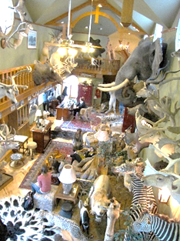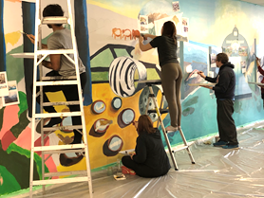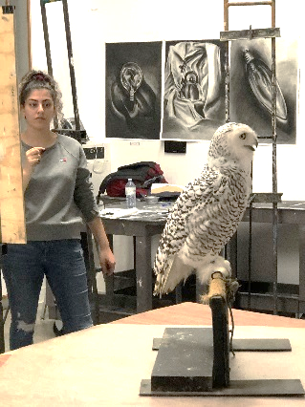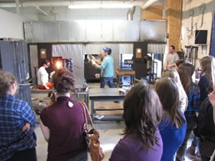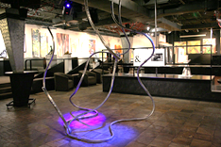
(clockwise- Scesczi Game Room , Elevate your Space Community Mural, Kingsport birds of prey, Tsunami Glassworks, Wellington offsite Graduating Exhibition 2010)
Teaching Methodology

The scope of degrees that our students are expanding into might be the widest range I have witnessed in 19 years. The range of student interests and capacities has always been diverse, but that seems to be amping up as of late. In the past, there were two types of students that were enrolled in our school – creatives and educators. The two students that I am going to discuss represent each end of that spectrum. Tina Rouhandeh (Emerging Artist) and Emily Fenos (Education)

Tina Rouhandeh

Four years ago a mature student Tina Rouhandeh, was enrolled in my fundamentals drawing class. Tina is an established artist with her own impressive practice. Her work was and is fascinating to me. I have never met anyone that is so intimately connected to their medium, in Tina’s case , thread. I have maintained contact with Tina since she was in my foundation courses and I have assisted her in assessing the sale of her work for permanent collections like the ROM and also provided multiple letters of support, both locally and federally. The work is exquisite, moving, it takes your breath away.

Working with Tina and so many Artists over the last 19 years has made me reassess my definition of scholarship and research, through my teaching methods. Teaching is for me the most immediate and pressure filled scholarly activity. Scholarship is generated by original thought. I consider a broader definition of scholarship to include the direct implications of my art criticism, which obviously is peer reviewed and discussed critically with students. Students utilize an instructor’s feedback directly for their own application purposes going forward. If an instructor is truly engaged, they themselves will experience a certain level of creative drain on their own work. Critical feedback and interpretation of work, day in and day out can only be described as scholarship, some are eventually our peers.

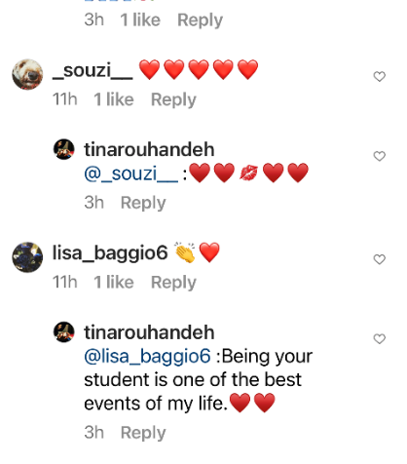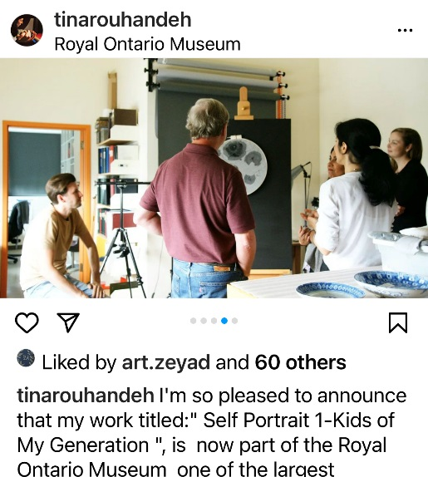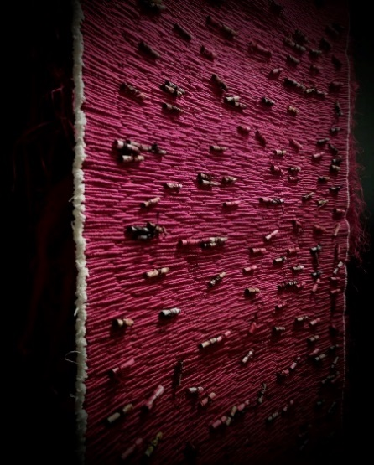

Windsor Endowment for the Arts (WEA)
P.O Box 7024
Windsor , Ontario
N9C3Y6

RE: Emerging Artists Grant March 22, 2022
Tina Rouhandeh
Inquiry about Forgotten Birds, Project
(Performance, Installation)

Tina Rouhandeh is a master calligrapher, scribe. Her work exceeds the political commentary of her birth home, Iran. Her work exceeds the transformative power of performance. Her work exceeds the object, the form.

She materializes ‘Loss’ through the process stringing, tying, twisting, threads and objects to represent a tapestry of longing, absence, persecution, suffering, death and hope.

I have never met, nor will I ever meet anyone like Tina. There is no line between her physical body and her work. I have never felt that way about any other Artist before, and I have known many. Through the thousands of hours that she has dedicated to her work, she embodies the ceremony of connection between the prayers and thoughts of Mothers, Fathers, Sisters, Brothers, Sons and Daughters and those that have been persecuted, incarcerated and murdered for their beliefs in Iran. The work is urgent and quiet, controlled and rebellious. Tina is in touch with the unseen, and unheard. You feel like you do not know what she knows, and you simply couldn’t know it.

Threads, twisted scrolls, objects, buttons and the beautiful bullion stitches have a sacred aura. The threads become, fluid, blood and blue veins under skin, and hair. The objects becomes a text and a language is created through markers on the surface.

Bits and tatters become clothing and ties become notches, ropes. The sounds of the loom’s drone-like thud and the compressed, pressured line of thread that is pushed into place, one after another, is symbolic and powerful. The silence in between the processes like the wrapping of thread around and around the needle…is deafening.

I am quite often at a loss for words in the presence of Tina’s work. The work clearly occupies a space that dwells upon a higher plane. You will be hard pressed to find a more dedicated Artist deserving WEA’s support to continue her project.

Do not hesitate to contact me with any questions that you might have.

L.Baggio

From: Tina Rouhandeh >
Sent: Monday, May 2, 2022 3:44:28 PM
To: Lisa Baggio <lbaggio@uwindsor.ca>
Subject: Sharing news.

Hi Lisa,
I hope you are doing well.
I'd just would like to share a great news with you.
My application accepted by Windsor Endowment for the Art.
Thank you very much for your help. Surely it could not have been done without your help.
I must admit that your letter was the most valuable support I have received during these past years.
Thank you so much Lisa !
With much love,
Tina

From: Tina Rouhandeh >
Sent: Wednesday, March 23, 2022 10:12 PM
To: Lisa Baggio <lbaggio@uwindsor.ca>
Subject: Re: done

Dear Lisa,
Thank you very much for taking the time to write this letter to me. Valuable, not because I need it to get a grant, but because reading your opinion about this collection really brought tears to my eyes. I always said that entering your class and getting to know you had a very important effect on my thinking process. I really cannot find a word to express my feelings.
Every sentence of this letter is like a precious piece for me that with each reading I can get more energy than ever to finish this project. I am happy and thankful that I am your student and I wish every art student has this chance.
It does not matter at all whether I receive the grant or not. Reading the opinion of a professional artist like you is more valuable than any award or grant and can give hope to anyone to continue...Thank you! Thank you!
I'll let you know the result once I receive it.

With much love,
Tina

Emily Fenos
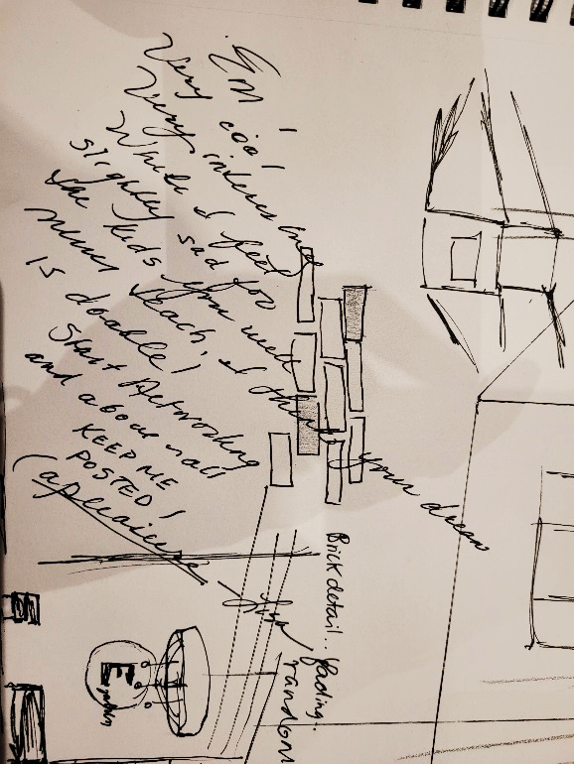

Good Morning Lisa! I wanted to write to you to thank you. I graduated like 3 or 4 years ago but you were always on me about becoming a teacher, so I did! I kept this sketchbook along with one of your drawings u doodled for me one day. You wrote that you would feel bad for the students that I didn’t get to teach. (Because I had another dream of opening an art studio) So I wanted to let you know that I am now working as a highschool occasional teacher with the hopes of one day snagging a visual arts contract position anyways THANK you, you have had a lasting impression on me that I will never forget, ever! Thanks so much LISA! been meaning to message you for a while. I’m happy it made you happy its all true. #1 professor out there!! Hope you are doing well!

I am never quite prepared, and certainly humbled when I receive notes like the one above many years after a student has left our program. The photo is note that I scribbled in Emily Fenos’ sketchbook in 300 level drawing. Four years after she graduated she felt compelled to write, an excerpt above, expressing her gratitude. I attempted during her time with us at SoCA to direct her away from an unrealistic plan and let her know there would be a deficit if she moved away from teaching. Emily was a natural educator. The scribble stuck with her and steered her in that direction when she was feeling a little lost. I don’t think we anticipate the weight of our words and our effectiveness as mentors or counselors. These stories can only serve to strengthen our positive community ties and caring elevates us all.
How does one find a common ground for each of these students to thrive in the same studio? One student fully engaged in an art practice and the other focused on the psychology of youth, and service through education. The only formula that works for me is this; create and environment of rigorous making, generate excitement, talk about the great masters in the arts, be humane and compassionate, share your failures and your successes. Leave notes, shake their hands and laugh.

If you are impactful they will reply in kind, even decades after the fact….

Lovely DMs, Jenn Kakoz (my student 13 years ago), Devon McCallum (my student 17 years ago).

7/13/22, 10:57 PM

Jenn

Hi Lisa! I don't know if you remember me but I was in one of your drawing classes my last year in my BFA undergrad ( at Label, 13 years ago). Jennifer Kakoz is my full name and at that time I focused my work on my family and specific objects. The sewing machine was one that I specifically linked with my mom. Anyways, I came across your facebook and really wanted to reach out and let you know how amazing of an instructor and person you were/are. I only had you once but the advice you gave me I'll never forget. You encouraged me to travel as much as I could and focus on myself in every healthy way. I ended up finishing teachers college right after art school and taught in England for a bit. After that, traveled lots and got married to an Italian from Hamilton. I remember you always jokingly teasing saying I was an 'Italian by association ' lol not a shocker that I'm married to one now I hope you are still instructing. Windsor is very lucky to have you. All the best and thanks for being so awesome. Jenn Kakoz

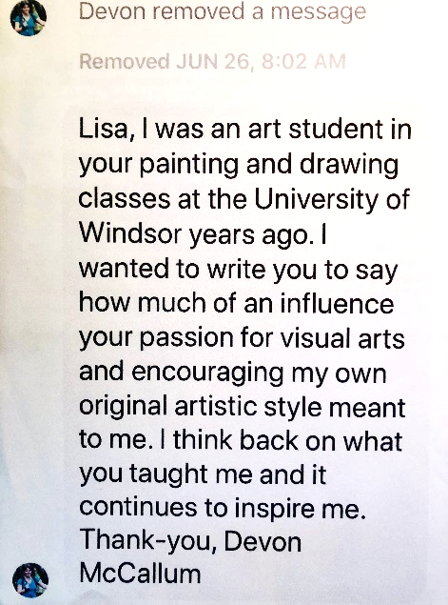

Closing

Everything must evolve and adapt to technological, environmental and social changes. SoCA is no exception.

In this document, I have shifted my focus from my approaches and theories of best practices, to simply focusing on the individuals that we teach. We can hypothesize and compare, theoretical adaptations vs. experiential applications but our success or failure is hinged on one question : are we fulfilling the needs of our students or are we not?

The employment requirements and job migration has shifted tremendously in the last 10 years and covid has accelerated those shifts. Geographically we are in a city with limited art patronage, minimal financial capital projects involving the arts and limited partnerships with private collectors, galleries and the global art market. These are all weighty facts.

When I was struggling to find a platform for the online graduating BFA exhibition in cold covid Winter 2021, I started scouring the trending job posts on Akimbo. The number of job posting that included 3D modeling, drawing and design was noteworthy. I began to discuss these programs with two students that were in the BFA graduating group- Ian Rawlings and Emily Roe. We brainstormed and researched the platforms and considered all of our options. We dreamed of designing an immersive experience where we could digitally place our final exhibition in a Community Space. We envisioned that in this outdoor exhibition a guest could walk around the space and freely zoom in and out of the site specific works of art and read small Artists statements on each piece. We asked the group if they were willing to learn and Kuula and SketchUp to transform our final online exhibition. Having one more virtual opening seemed to add to the stress of once again being home bound. I am proud of how the students rallied and embraced the ‘new’. It was an enormous learning curve.

The BFA group learned how to recreate digital versions of their work and plant it into a dead ringer that they fabricated of the LaSalle Civic Center. It could not have been more successful and memorable. I was absolutely speechless…and to this day students in that group continue to send feedback on how learning SketchUp, Enscape, Kuula and Wix, have since come into play in their applications.
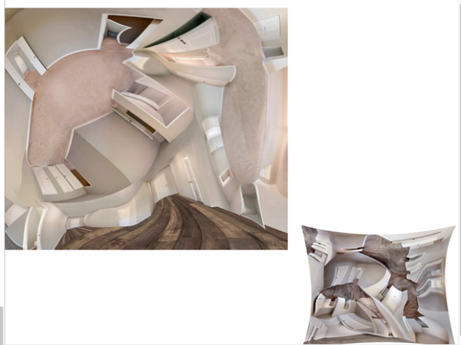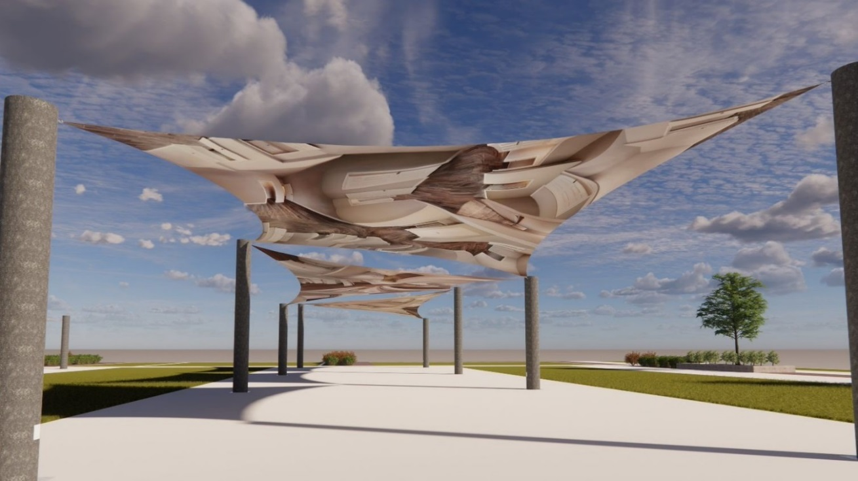
Emily Roe – Home Sweet Home
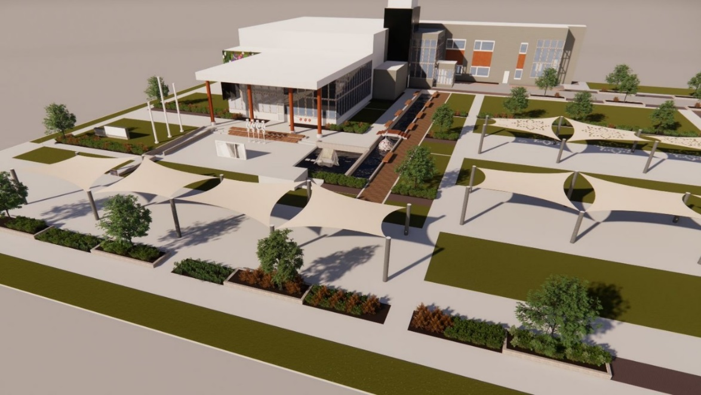

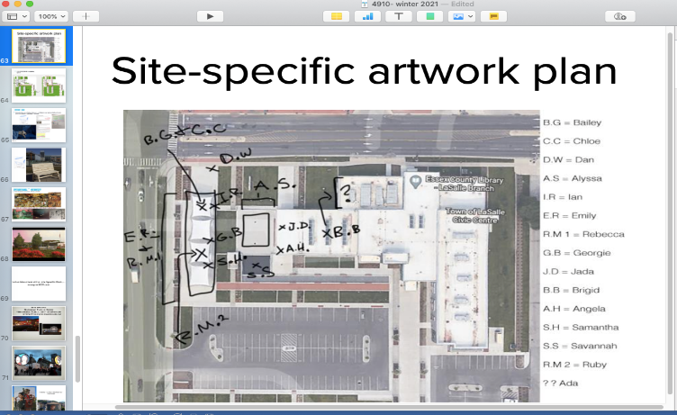

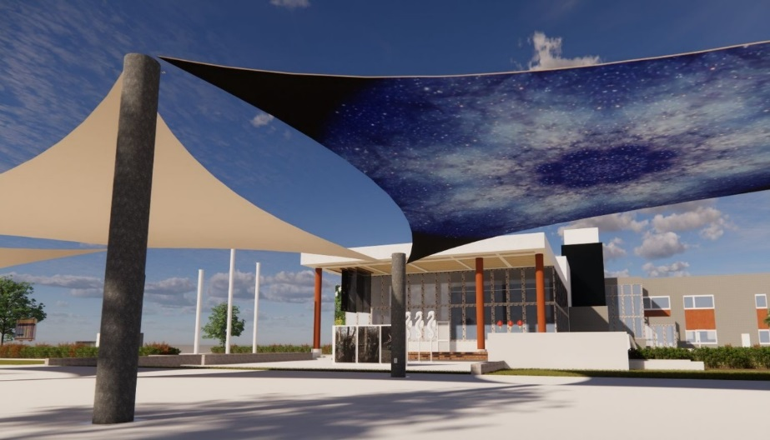
Ruby McKinnon- Constellation

In closing I want to say this, knowing full well this is a grand discussion for another day, if we truly want to mentor these students we must rethink our mission. What can this beautiful art school be?

Everything must evolve and adapt to technological, environmental and social changes. SoCA is no exception.

If covid has taught us anything, it is that with some discomfort we can mobilize a tremendous shift in our teaching practices and as a result in our school. We should sit with that lesson of mobilization for a while.

Thank you,

Lisa
you for
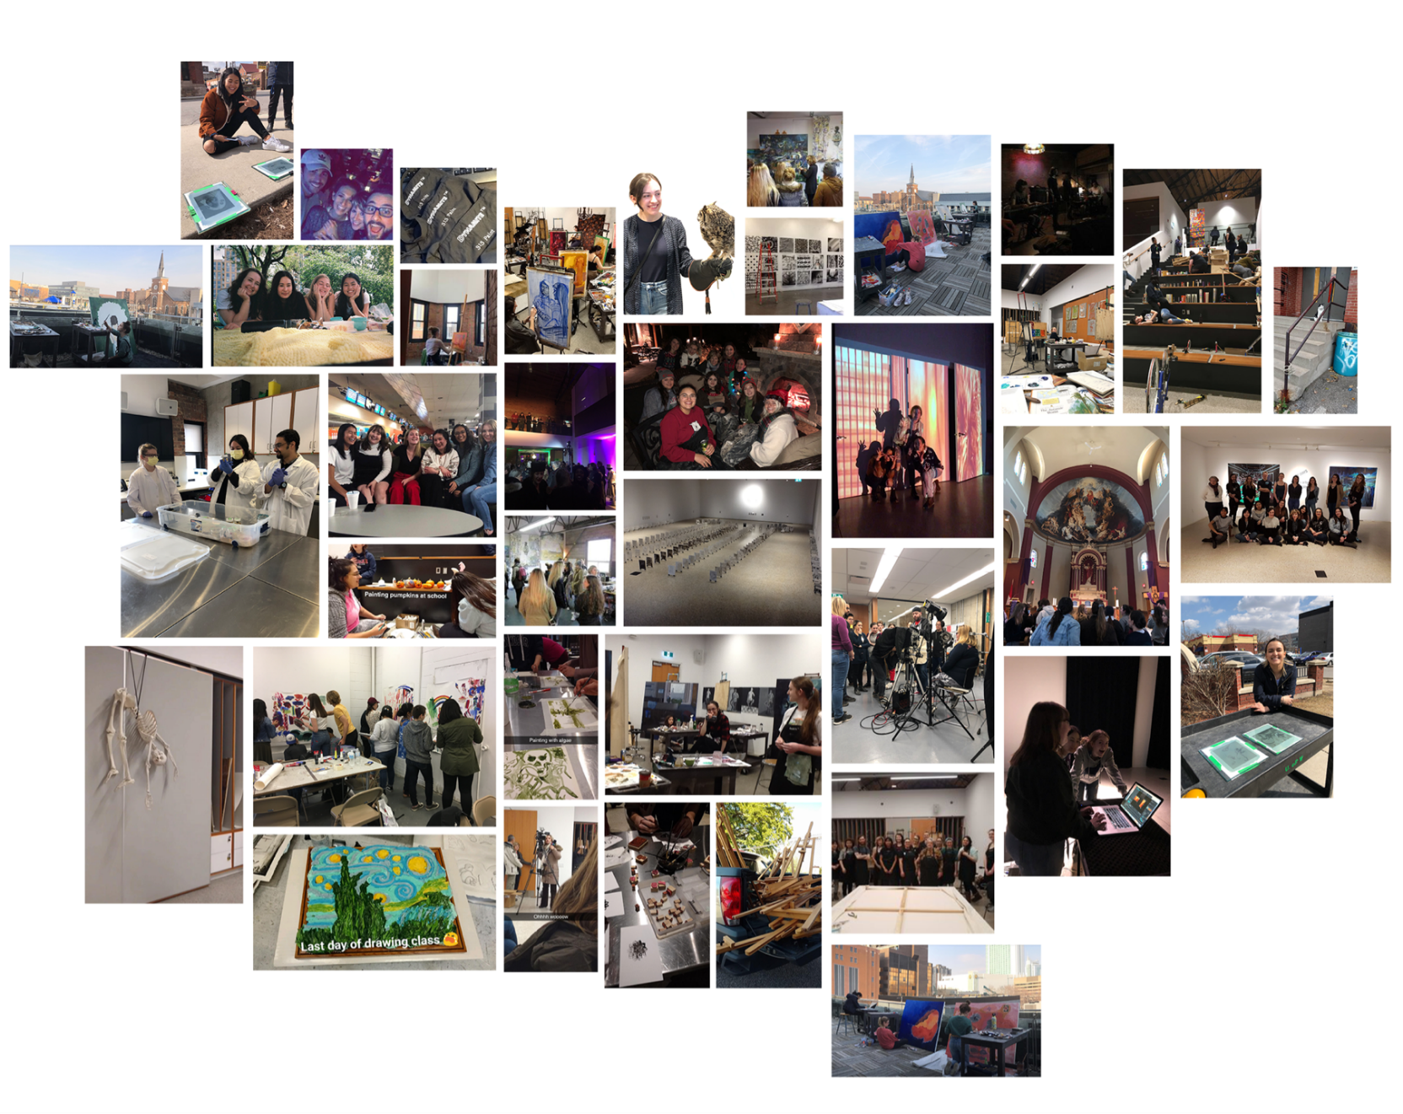

* 2017 SUBMISSION – ONGOING
Pedagogy- Research Objectives 2017/2019

More than a decade ago the perpetual looming question was; What will happen to studio after technology (tech)? I think it is now safe to say that the resounding answer to that question is…almost nothing. Studio is an odd animal, resilient and unaffected by tech in many ways. The hand will always be the interface between the idea and the development of that idea - the work. Tech in studio has not eclipsed the hand, but has provided the user with an unidentified and debilitating side effect in studio…paralysis.

Tech has infected studio in the form a two-fold pathogen, escalation of expectation and paralysis of choice.

Over the last decade I have witnessed an escalation of student’s expectations. In my opinion, the choices that are available to most students are so vast that I fear that they are developing an unrealistic view of potential outcomes. It affects their wellbeing, happiness, and their work.

Students have communicated repeatedly that they are completely dissatisfied with the results of their efforts and they speak of their work with low level apathy. It seems evident, after reviewing process submissions, that there is little or no documented ownership of their concepts, development, or attempt at research. Their work in progress looks like a manic shopping spree, where they want to fit absolutely everything they can get their hands on, into the cart. They expect their work to resemble completed work that they view online. They surf, and misappropriate and are completely detached to the things they say they are interested in. I began to think how much happier they would be, if they could readjust their expectations.

Access to infinite possibilities and sources leads to a paralysis of choice. Students don’t trust their own ideas and ability to execute them so they use images that don’t work, don’t fit and most importantly are not theirs. They detect this but are incapacitated to circumvent it. As a result, they stop participating in their own work. In short, our students fail to engage in their own work because they are overwhelmed as a result of too many choices, and unmanageable stimulation.
I refuse to accept that studio faculty are powerless against the technology hijacking that is taking place. I think there is a solution, which I believe to be a reprogramming with “Idleness”.

I recognize that my anti-tech sentiment is not new, but I am proposing a temporary reprogramming. What if within a small segment of their creative education, (studio fundamental and introductory studio) they are denied some access to the murky carnival that is just a click away?
This conclusion has forced me to consider how I could expand my base of expertise. What was previously skill and knowledge based activity in studio is now going to have to be saddled with a counter deprogramming methodology (sorry Sigi!)
Across the board our expertise lie in the cultivation of creative problem solvers. Fundamentals courses and entrance level discipline courses harbor a distinct responsibility; building blocks of original thought and processes associated with the same.
I have engaged in 3 models of research and idea cultivation that have provided an incredible body of work at a Foundation Level and Introductory Level. The feedback from students has been consistently positive. I will outline the 3 methods (strategies) in Teaching Methodology. (p 5-10)

- Nothing is yours…unless you make it.
- Nothing is neutral.
- Idleness: what-the-fuck-give-it-a-try.*
*Robert Storr-Yale University
Teaching Methodology 2017

THE PROBLEM: OWNERSHIP AND PRODUCTION

THE PROPOSED SOLUTION: Tech free data collection excursions, site specific to a Directive or Independent Project. Connect to the world by observing, recording, interpreting, making, and editing.

THE STUDENT:
Finding generational theories was quite simple and in my opinion, quite accurate.
Generation Y, 20 years old in 2010. Tech shrewdness, slightly earthy, connected, and happy. I could relate, I could work with that. They seemed slightly bored on data collecting excursions, it did not break my spirit, I detected that I was on-to-something.
Generation Z, 20 years old in 2017. Lives, works, thinks, plays, and interprets with a new set of rules. Tech saturated, distant, more introverted, completely lacking naiveite and as a result a little cynical. Tech protocol and bandwagon effect via tech is a huge problem and they have RULES. These standards and this behavior all seemed a little difficult to break through. I did not need a theorist to confirm what I had already identified as a problem. I did notice that I had something they, the Z’ers, don’t seem to have access to … THE WORLD, the palpable actual world. The dusty one, with rain and rivers, broken things, loud noises, unpleasant smells, interesting people, and nature. They don’t seem to touch it, use it, smell it, or interpret it much. As a result, data collecting methods and models in the world, are actually novel and exciting. This ongoing experimentation has changed everything for me.
In the last 6 years, I have completely revised my fundamentals and intro level courses to reflect these new models to accommodate this new breed of student.
Expanded practice in studio simply means, expansion upon beautiful traditions in studio and staying ahead of the fallout of tech. Studio does not have to dilute its agenda to accommodate tech and students are reaping the benefits of pure concept cultivation. We are a multidisciplinary program and there is an enormous amount of tech expertise waiting for them within the branches of the program.
I have found myself experimenting increasingly with methodology against the availability of image, source, information via tech.

I have attempted to summarize the three methods that are the cornerstone of all my fundamentals and introductory level studio practices. No tech permitted.
- Nothing is yours…unless you make it.
- Nothing is neutral.
- Idleness: what-the-fuck-give-it-a-try.

- Nothing Is Yours (unless you make it)
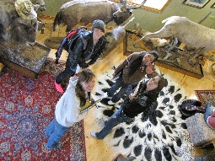
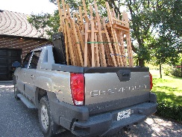
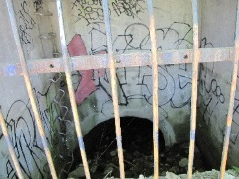
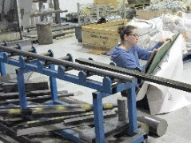
To circumvent the ownership crisis in all things visual, I require students to cultivate their sources on site, simultaneously and – by hand. I use data collecting trips to odd, symbolically loaded, geographically relevant places, at which time, swift drawing or painting data is collected. Digital recording is not permitted. They feel, smell, access memories and experience little urgency or agenda. Rural settings, busy streets, parking lots, wastelands, strange stores, collections, dumping grounds and abandon churches. No tech permitted, and cell phones turned off. This allows students to move about in a larger space and use the format for recording that they are most comfortable with. Follow-up work in studio uses only the data they collected, in addition, theoretical discussions, and examples of symbolic implication are presented. Building rapport with the students seems to be more natural by removing them from the formal education model and traditional indoor studio spaces.
RESULT= A new aesthetic is cultivated, a completely novel approach, a struggle, and an enormous amount of editing. They slow down and recognize their participation in documentation. They feel pride around the urgent, honest data collected. They collaborate much more in these new locations than in studio.
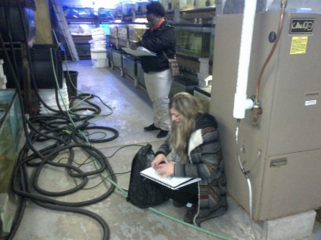
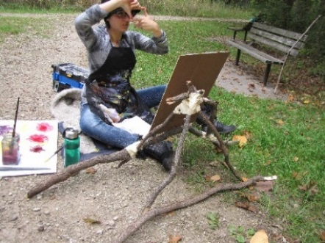
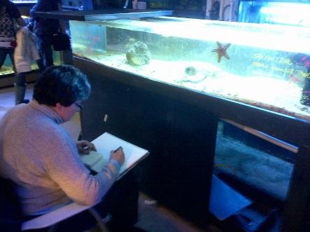

- Nothing Is Neutral

One of the imposing obstacles in creative disciplines is authenticity. Now, more than ever before, I witness students using imagery that they have no connection to. Additionally, they generally fail to understand the context of these sources. Image junkies…image porn…mass production culture. Students surf, utilize and misinterpret imagery at warp speed. If technology, which in itself is not neutral, is eliminated from the equation and the onsite data collection is inserted; chronology, narrative and construction are then magnified. History is not a forced consideration while the data is collected on these trips, students are excited to see what they have unknowingly tapped into. Back in studio referencing lineage of a genre as a lead in to theory is the best was to prevent the student from being overwhelmed, confused, or discouraged.

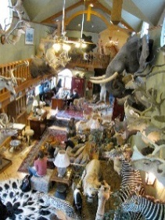
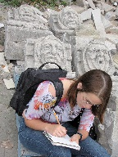
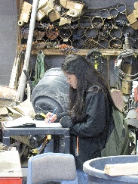
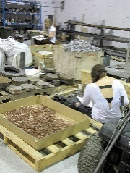
RESULT= Anticipation of executing work without prep has its own level of anxiety and awareness. On site, the work begins to take on a new free form expression as they engage in their own interpretation. Early stage data defies categorization, and the final solutions are raw and imaginative. I can assist in the process and begin to make theoretical connections. It is a contagious energy.
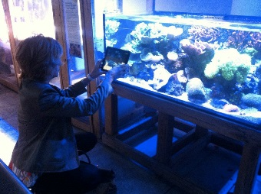
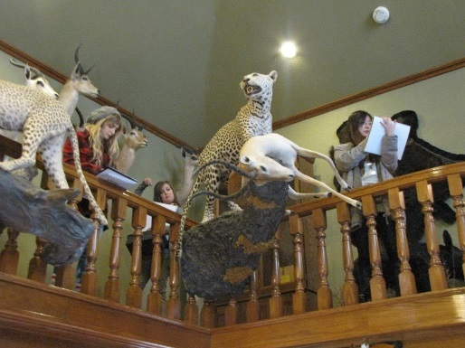
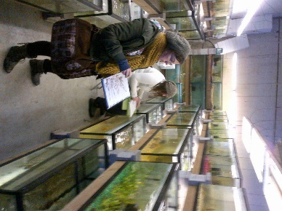

- Idleness - what-the-fuck-give-it-a-shot *
Learning the unrealized possibility of idleness in a space, is compelling. If you are idle…you are not consuming. I think this Gen. Z student is becoming fatigued by consumption. I give students the option to work or not on certain trips. Students want to talk and are ready to engage in discussions with their peers. We engage in a mini WIP crits on site, they are very productive and I think students detect the level playing field. Students learn the difference, as I have, between destructive and constructive criticism. For me, reinforcement is the most interesting part of making and this is where it is most valuable. Simplicity and being in control of pace is completely foreign to our students. They love it.
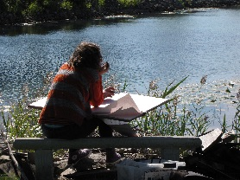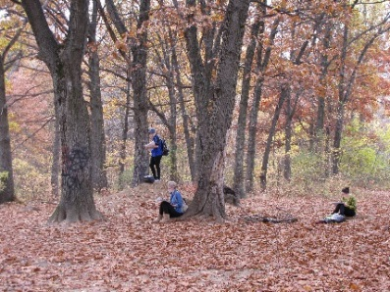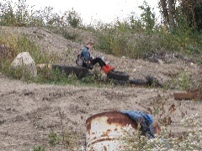
RESULT= Students are completely engaged in the process. They never want to return to LeBel. Expanded field of practice v. retracted filed of practice. Students recognize the difference between MAKING and CONSUMING at this point and a certain type of situational aesthetic develops. Ultimately ownership is the goal and with very few exceptions, it is the result.

These processes are somewhat innovative and I am quite rigid about their participation. Students are reluctant yet cooperative at first, and then they settle in and make. As the final days of the course draw to a close, the feedback that I receive from the students is extremely positive about these processes. The work that is produced is solid, authentic, and quite strong.

OPEN STUDIO

Lastly, I utilize my studio as a teaching tool. I invite students into my personal space to discuss the process that I use to problem solve with my own work, not unlike the methods discussed. This last trip was particularly moving for me and for the students, as described by a participant below, Ashley Spina.

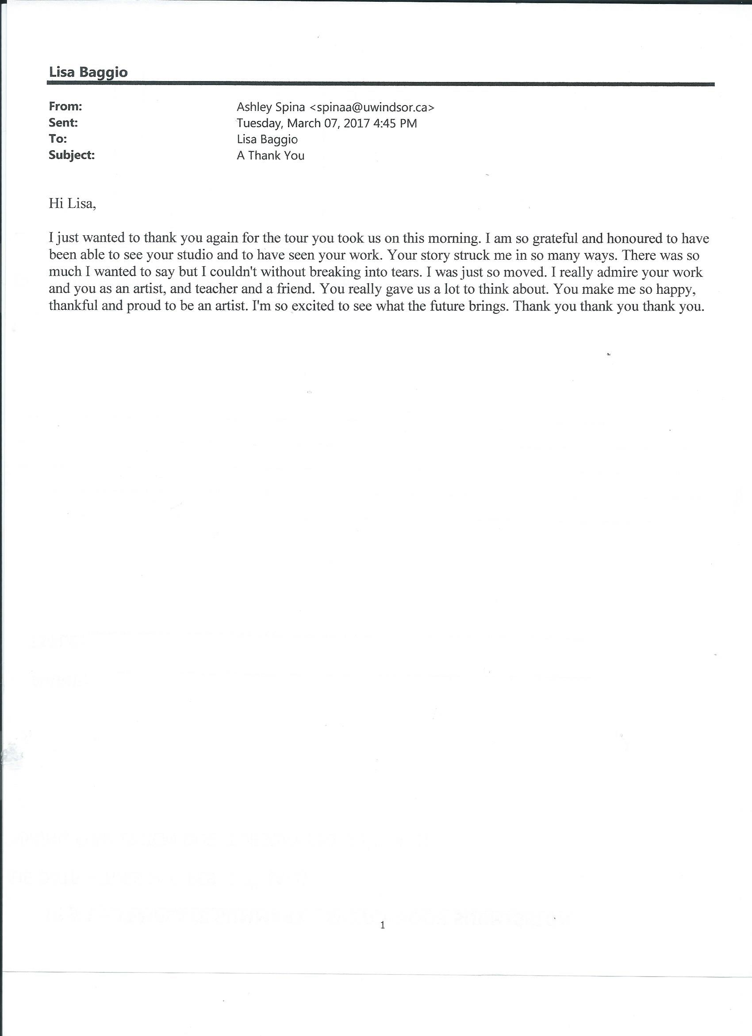
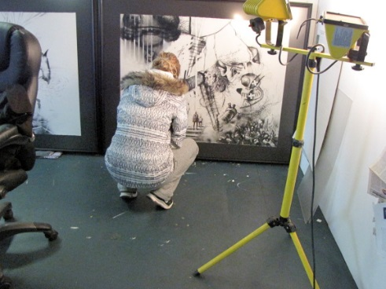
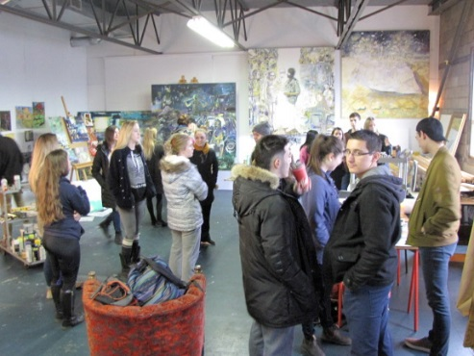

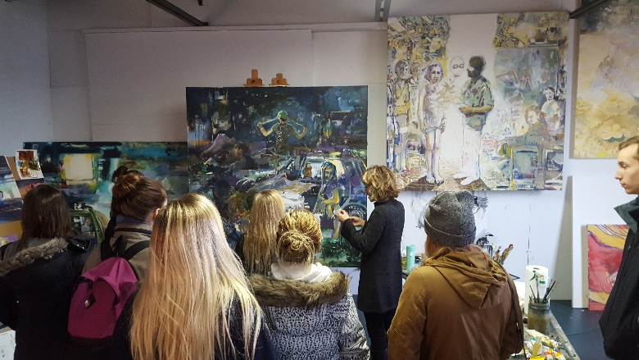

TAB #4 - All Course Syllabi can be found in HARD COPY

Tab #5 SERVICE TO THE UNIVERSITY - Initiatives
(see HC tabs for further information)
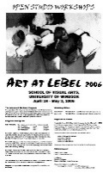

2004/05 - Open Studio Workshops
Recruitment Project

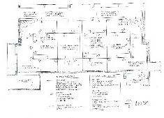
2005/06 - Capital Project- LeBel Gallery
Fundraiser- $80k



2007 - Gallery Renovation Project Kickoff
Alumni Exhibition- Flourish

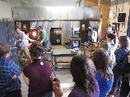

2008/14 - Tsunami Glassworks Inc.
Eva Milinkovic, studio visits and demos

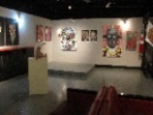

2010 - Offsite BFA Graduating Exhibition

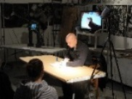

2011|12 - David Finch Lecture Series
DC Comics, Marvel Comics
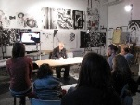

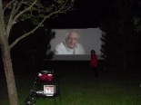

- - Movie Night Orientation Project

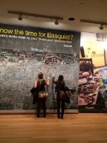

2014|15 - Basquiat Toronto Weekend VA+CMF



2016 - Monster Draw
Recruitment Secondary School



2016|2017- Prints Charming - Deaccession Print Collection, Scholarship Fundraiser

2018|2020- Elevate – Community Mural Project 58’x10’

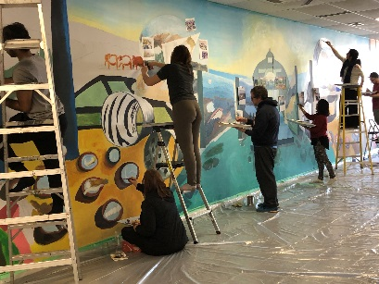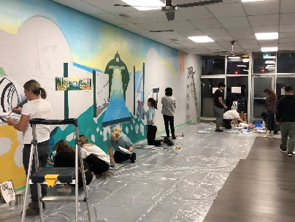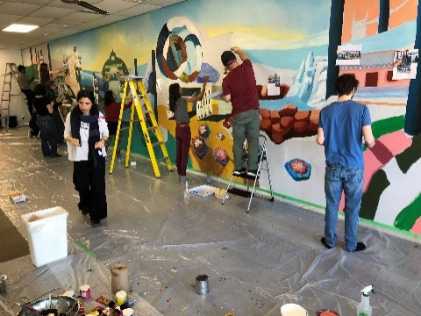
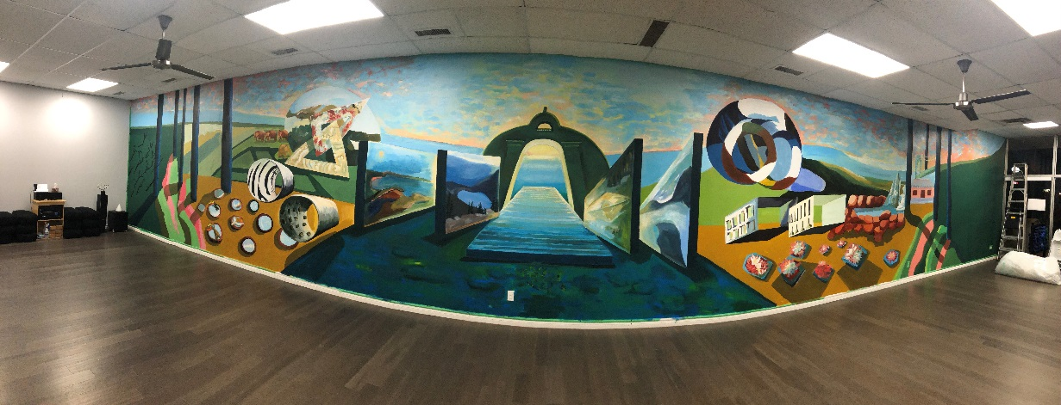
ELEVATE YOUR SPACE – DIRECTOR, DESIGNER, ARTIST
2018-2020
Elevate your Space is an ongoing public indoor mural project that serves to educate, incorporate and facilitate public creativity and connection to space. Over 50 non-artists participated in the design and execution of a 500 square foot mural. Participants were asked to compile images of a transformative space that they have encountered in their travels or daily lives. The execution involved senior students within SoCA and the education department at the University of Windsor. Most importantly the general public became artists and critics and it was an overwhelming success.
(PLEASE SEE THE TIMELAPSE VIDEO IN “ lisabaggio.com -Projects”)

Tab #6

DATA FOR BAR GRAPHS  19 Years Teaching Activity *  Course Description | Course # | Semester | Year | Enroll. | Instructor Score | Course  Score | Department Averages
 |  |  |  |  |  |  | Instr. | Course
Studio Practice Ideas Drawing  Intro Painting | AR1070-01  AR2130 | Winter  Winter | 2022 | 18  19 | NA  NA | NA  NA | NA  NA | NA  NA
ONLINE  Studio Practice Ideas Drawing  Studio Practice Ideas Drawing  Critical Issues  Independent Studio  Intro. Painting  Studio Practice Ideas Drawing  Studio Practice Ideas Drawing  COVID TRANSFER COURSE LOAD 2020 FALL TO WINTER 2021 | AR1070-01  AR1070-02  AR4910-01  AR3650-04  AR2130-01  AR1070-03  AR1070-01 | Fall  Fall  Winter  Winter Winter  Winter  Winter | 2021 | 24  23  16  1  15  20  11 | 6.2  6.2  7.0  NA  NA  6.1  4.7 | NA | NA | NA
Intro. Painting  Arch. Design II  Intro Drawing | AR2130-01  BE2100-S2  AR2030-01 | Winter  Winter | 2020 | 20  22 | No SET  No SET | NA | NA | NA
Studio Practice Ideas/Image  Independent Studio  Studio Practice Ideas Drawing  Studio Practice Ideas Drawing  Studio Practice Ideas Drawing  Intro. Drawing  Arch. Design II | AR1060-02  AR3650-02  AR1070-01  AR1070-30  AR1070-01  AR2030-01  BE1200-S2 | Fall  Fall  Fall  Fall  Winter  Winter | 2019 | 25  1  23  24  25  12  13 | 6.3  Na  5.5  6.4  6.5  6.6  6.1 | 6.3  NA  5.3  6.0  6.3  6.1  5.8 | 5.8  5.9 | 5.7  5.8
Studio Practice Ideas Drawing  Independent Studio  Intro Drawing  Studio Practice Ideas Drawing  Drawing  Painting  Studio Practice Ideas Drawing | 27-107-30  27-365-01  27-203-01  27-107-01  27-303-01  27-313-01  27-107-01 | Fall  Fall  Fall  Fall  Winter  Winter  Winter | 2018 | 22  1  15  24  17  10  25 | 6.5  NA  6.5  6.3  6.4  6.9  6.3 | 6.2  NA  6.3  6.3 | 5.7 | 5.8
19 Years Teaching Activity *  Course Description | Course # | Semester | Year | Enroll. | Instructor Score | Course  Score | Department Averages
 |  |  |  |  |  |  | Instr. | Course
Arch Design II  Intro. Drawing  Studio Practice Ideas Drawing | 36-120-01  27-203-01  27-107-01 | Winter  Winter Winter | 2017 | 11  14  16 | 6.3  6.6  6.1 | 5.7  6.3  6.0 | 5.2 | 4.5
Intro. Painting  Studio Practice Ideas Drawing  Studio Practice Ideas Drawing  Arch Design II  Intro. Drawing  Studio Practice Ideas Drawing  Intro. Painting | 27-213-01  27-107-30  27-107-02  36-120-01  27-203-01  27-107-01  27-213-01 | Fall  Fall  Fall  Winter  Winter Winter  Winter | 2016 | 11  24  21  11  14  12  19 | 6.0  6.4  5.8  5.7  6.5  6.1  6.2 | 5.9  6.1  5.7  5.5  6.3  5.9  6.1 | 4.9 | 4.8
Studio Practice I  Studio Practice II  Intro. Painting  Studio Practice Ideas Drawing  Arch. Design II  Indep. Studio  Intro Drawing  Studio Practice Ideas Drawing | 27-480-01  27-481-01  27-213-01  27-107-01  36-120-01  27-365-01  27-203-01  27-107-01 | Fall  Fall  Fall  Fall  Winter  Winter Winter  Winter | 2015 | 5  6  23  22  11  6  14  24 | No SET  No SET  No SET  6.1  6.2  No SET  6.2  6.4 | -  -  -  6.0  6.1  -  6.1  6.2 | 5.9 | 5.7
Intro. Painting  Intro. Drawing  Studio Practice Ideas Drawing  Intro. Painting  Intro. Painting  Studio Practice Ideas Drawing | 27-213-01  27-203-01  27-107-30  27-213-02  27-213-01  27-107-01 | Fall  Fall  Fall  Winter  Winter  Winter | 2014 | 21  23  23  17  17  18 | 6.1  6.3  6.1  6.8  6.5  6.2 | 5.9  6.0  6.0  6.8  6.6  6.0 | 5.8 | 5.7
Intro. Painting  Studio Practice Ideas Drawing  Studio Practice Ideas Drawing  Arch. Design II  Independent Studio  Drawing  Intro Drawing  Studio Practice Ideas Drawing | 27-213-01  27-107-30  27-107-01  36-120-01  27-365-04  27-303-01  27-203-01  27-107-01 | Fall  Fall  Fall  Winter  Winter  Winter  Winter  Winter | 2013 | 23  25  23  6  3  22  16  23 | 6.1  6.5  6.1  6.4  -  6.5  6.3  6.3 | 6.1  6.4  5.8  6.0  -  6.4  6.2  6.0 | 5.8 | 5.6
Drawing  Studio Practice Ideas Drawing  Studio Practice Ideas Drawing  Intro. Drawing  Studio Practice Ideas Drawing  Studio Practice Ideas Drawing | 27-303-01  27-107-30  27-107-01  27-203-02  27-107-02  27-107-01 | Fall  Fall  Fall  Winter  Winter  Winter | 2012 | 24  27  22  21  24  23 | 6.2  6.4  6.2  6.6  6.8  6.5 | 6.1  6.2  6.1  6.4  6.6  6.4 | 5.7 | 5.6
Course Description | Course # | Semester | Year | Enroll. | Instructor Score | Course  Score | Department Averages
 |  |  |  |  |  |  | Instr. | Course
Studio Practice Ideas Drawing  2D Image  Studio Practice Ideas Drawing  Studio Practice Ideas Drawing  Studio Practice Ideas Drawing | 27-107-01  27-106-02  27-107-30  27-107-02  27-107-01 | Fall  Fall  Fall  Winter  Winter | 2011 | 25  24  27  23  26 | 6.4  6.3  5.9  6.3  6.3 | 6.3  6.2  5.8  6.2  6.1 | 5.6 | 5.5
Arch Design II  Intro. Drawing  2D Image  Intro. Drawing  Studio Practice Ideas Drawing | 36-120-01  27-203-01  27-106-01  27-203-02  27-107-30 | Fall  Fall  Fall  Winter  Winter | 2010 | 16  23  11  18  23 | 6.0  6.5  6.1  6.1  6.9 | 6.0  6.2  6.1  5.8  6.8 | 5.7 | 5.4
Intro. Drawing  Studio Practice Ideas Drawing  Studio Practice Ideas Drawing  Studio Practice Ideas Drawing | 27-203-01  27-107-01  27-107-30  27-107-01 | Fall  Fall  Fall  Winter | 2009 | 22  21  21  23 | 6.3  6.5  6.4  6.0 | 6.3  6.3  6.3  6.0 | 5.9 | 5.8
Intro. Painting  Studio Practice Ideas Drawing  Intro. Drawing | 27-213-02  27-107-30  27-203-01 | Fall  Fall  Winter | 2008 | 21  23  14 | 6.3  6.2  6.2 | 5.8  6.1  6.1 | 5.9 | 5.7
Intro. Painting  Intro. Drawing  Studio Practice Ideas Drawing  Drawing  Intro. Painting | 27-213-01  27-203-01  27-107-30  27-303-01  27-213-01 | Fall  Fall  Fall  Winter  Winter | 2007 | 14  19  24  19  21 | 6.1  6.2  6.2  5.4  5.9 | 6.0  6.1  5.9  6.1  5.9 | 5.8 | 5.6
*teaching activity years
2004-07 avail on eCV – SOST system with 4.0 score range.
1995-96 – Group Instr. Structure Fundamentals 100 with:
Rachelle Vaider Knowles
Wayne Thibault
Rod Strickland

